Trinity Education Project: Resources
The Trinity Education Assessment Framework

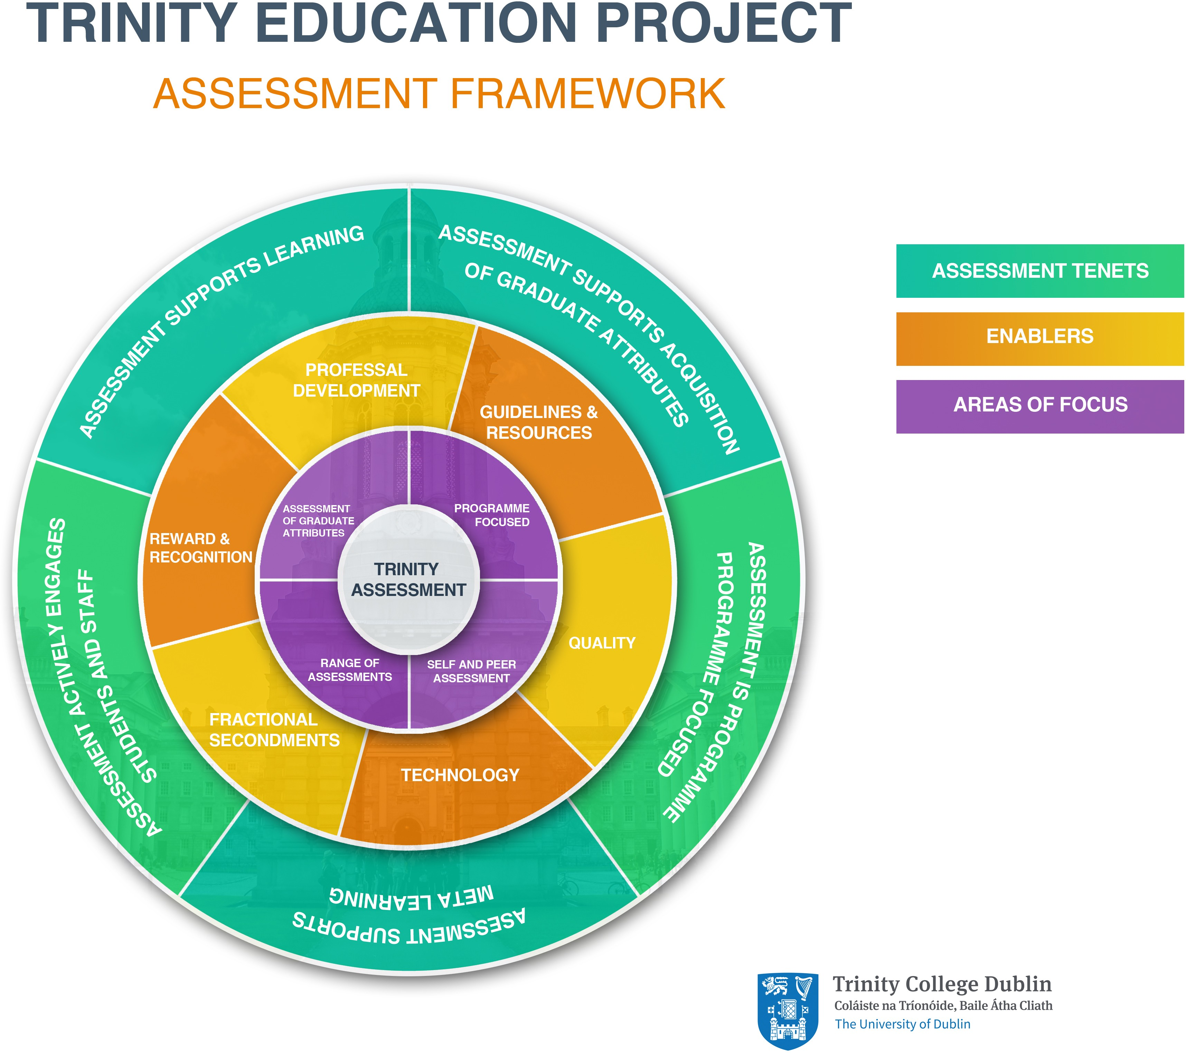

What aspect of TEP does this resource refer to?
This resource summarises key points of the Trinity Assessment Framework, approved by Council in May 2016.

Rationale for the Trinity Assessment Framework
The literature describes three main purposes of assessment: (a) Assessment OF learning (to demonstrate achievement); (b) Assessment FOR Learning (to give feedback on learning and teaching); and (c) assessment AS Learning (to self-­‐regulate and critically evaluate). While summative assessment (assessment OF learning) is a necessary and important form of assessment, the traditional concept that assessment consists primarily of examinations and essays has been challenged over the last decade. It is acknowledged that the increased complexity of learning needed for the 21st Century graduate cannot be adequately assessed through examinations alone.¹ The assessment framework advocates a programme approach to assessment to encourage fewer, more meaningful assessments across the academic curriculum.

- OECD, High level group on modernization of higher education. Report to the European Commission on new modes of learning and teaching in higher education.

What is a programme focus on assessment?
A programme approach to assessment (or where the programme is very large, a subject approach) establishes the full picture of assessments across a programme of learning and presents assessment and feedback ‘as a linked series of learning opportunities across the whole programme’.² A programme approach to assessment can facilitate a move from the current strong focus on assessment of learning towards assessment for and as learning as well as increase opportunities to assess graduate attributes. By spotlighting duplication and supporting integration of assessment(s), this approach also creates space for a range of assessment types e.g. reflection on learning, independent project work, group work, field trips and other forms of individual and collaborative learning. A programme focus on assessment thus enables: (a) a planned and coordinated approach to the design and inclusion of assessments across a programme, (b) an appropriate range and balance of assessments ‘of’, ‘for’ and ‘as’ learning, (c) evaluation of assessment(s) in an integrated and longitudinally oriented manner and (d) collaboration between various contributors to the programme.

What is represented in the Trinity Assessment Framework diagram?
The Trinity Assessment Framework recommends that Programmes in the Trinity Curriculum be designed to include a range of appropriate assessment strategies and tasks that support effective learning, provide students with opportunities to practice new forms of assessment, and enable achievement of the full spectrum of graduate attributes. The framework is cyclical and represents an institutional approach that encourages ownership and development of an effective and innovative assessment strategy. It has three interrelated layers: Tenets; Enablers; Areas of Focus.

The first layer (outside circle) shows the tenets, or underpinning principles that inform assessment in Trinity. The middle circle delineates institutional enablers of assessment change. The innermost circle represents the areas of current focus. Collectively, the framework depicts a structure for enabling transformation in assessment practices and policy in Trinity.

Assessment tenets
Assessment in Trinity will:
  - Support the acquisition of graduate attributes;
  - Support learning;
  - Be programme-­‐focused;
  - Support meta-­‐learning;
  - Actively engage students and staff.

- Jessop, T., El Hakim, Y., & Gibbs, G. (2014). ‘The whole is greater than the sum of its parts: a large-­‐scale study of students’ learning in response to different programme assessment patterns’. Assessment and Evaluation in Higher Education. 39:73-­‐ 88.

Assessment supports the acquisition of graduate attributes
Graduate attributes are embedded and assessed incrementally and systematically throughout the programme, through a diverse and complementary range of assessments.

Assessment supports learning
Assessment is valid, reliable, transparent, relevant and conducive to effective learning, whilst protecting academic standards. It supports future as well as present learning.

Assessment is programme-­‐focused
Assessment is an integral part of programme design and development. A range of purposeful assessment tasks are mapped and integrated throughout a programme. By shifting the focus away from end-­‐of-­‐year summative assessment, more integrative assessment practices are considered.
Assessment supports meta-­‐learning
Assessment builds and rewards student ability to reflect on and critically evaluate their own learning, and to assess the quality of their performance against agreed standards. Assessment also builds student capacity to use these skills of judgment to influence future learning and practice.

Assessment actively engages students
Real world/authentic assessment tasks engage students in learning. Dialogue about the assessment process is encouraged amongst and between staff and students so that the purposes and standards of assessment are understood.

Assessment enablers
Constructive change in assessment practices/policy in Trinity is enabled by development of an infrastructure to support change. The following areas are considered essential enablers:

- Professional Development
- Fractional secondments/sabbaticals to Academic Practice
- Quality (including curriculum review and development)
- Technology
- Guidelines and resources
- Reward and recognition

Areas of focus
The following areas of focus are integral to the framework and to enhancing assessment in Trinity:
  - Assessment of Graduate Attributes
  - Programme-­‐focused assessment
  - Range of Assessment
  - Self &Peer assessment
Focused professional development and college wide discussion have accompanied these areas of focus in 2016 and 2017, which are likely to change over time.

